PRO-LIFE RALLY & MARCH  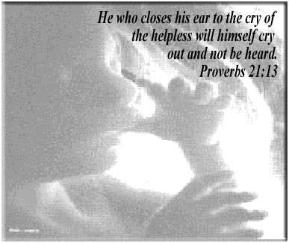  Saturday, January 14  10:45 AM  Brother Bryan Park  22nd Street South at 10th Avenue  Birmingham, AL  Rain or Shine - Legal & Peaceful  Bring Your Kids And Come Celebrate Life!  205.252.0706 ext 30  www.SanctityofLifeMinistries.org  "The United For Life Committee believes in the sacredness and dignity of every human being from the moment of conception to natural death. We are pledged to non- violence in thought, word, and deed and committed to exhibiting the sacrificial love of God in Christ Jesus, The Lord. Therefore, we renounce and condemn the use of violence to overcome the violence of abortion, and we respect the dignity of every human being, pre-born and born, friend and foe alike” | PRO-LIFE RALLY & MARCH  Saturday, January 14  10:45 AM  Brother Bryan Park  22nd Street South at 10th Avenue  Birmingham, AL  Rain or Shine - Legal & Peaceful  Bring Your Kids And Come Celebrate Life!  205.252.0706 ext 30  www.SanctityofLifeMinistries.org  The United For Life Committee believes in the sacredness and dignity of every human being from the moment of conception to natural death. We are pledged to non- violence in thought, word, and deed and committed to exhibiting the sacrificial love of God in Christ Jesus, The Lord. Therefore, we renounce and condemn the use of violence to overcome the violence of abortion, and we respect the dignity of every human being, pre-born and born, friend and foe alike”

